**Dragino NBSN50-NB AT Command Sets**

|  |  |  |
| --- | --- | --- |
| Version | Describe | Time |
| V1.0 | Release | 2020-Mar-7 |

目录

1 Introduction 3

1.1 How to connect device and send AT command? 3

2 General Command 5

2.1 AT: Attention 5

2.2 AT?: Short Help 5

2.3 ATZ: MCU Reset 5

2.4 AT+TDC: Application Data Transmission Interval 6

2.5 AT+CFG: Print all configurations 6

3 Mqtt management 6

3.1 AT+UNAME: Application Username 6

3.2 AT+PWD: Application Password 7

3.3 AT+CLIENDID: Application cliendID 7

3.4 AT+SERVADDR: Device Address 8

3.5 AT+PUBTOPIC: Device EUI 8

4 Information 8

4.1 AT+FDR: Factory Data Reset 8

4.2 AT+ DISAT: Disable AT Commands 9

4.3 AT+ PWORD: Password 9

Introduction

This article describes the AT Commands Set used in Dragino NB-IoT products, it covers below products:

* NBSN50 NB-IoT I/O Controller

How to connect device and send AT command?

Software Setting:

An USB-TTL can be used with standard windows software such as Serial Port Utility. The chosen software should be configured with the following parameters:  
• Baud rate: 9600  
• Data: 8 bit  
• Parity: none  
• Stop: 1 bit  
• Flow type: none

Figure 1 show the standard configuration for Serial Port Utility to use USB-TTL.

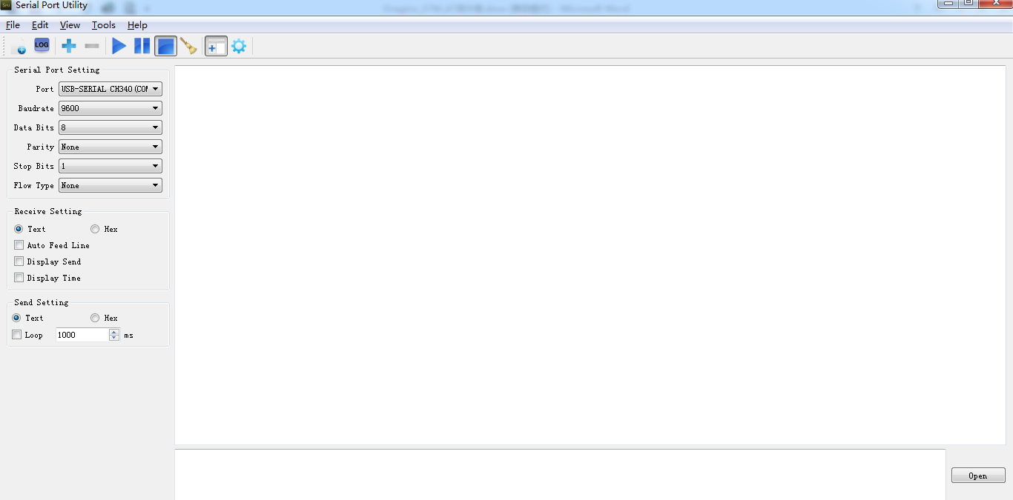

All the AT commands have a standard format as “AT+XXX”, with XXX denoting the command. There are four available command behaviors:  
• **AT+XXX?** provides a short help of the given command, for example **AT?**  
• **AT+XXX** is used to run a command, such as **AT+JOIN**  
• **AT+XXX=?** is used to get the value of a given command, for example **AT+TDC=?**  
• **AT+XXX=<value>** is used to provide a value to a command, for example  
**AT+SENDB=12:12a0ff**  
The output of the commands is provided on the UART. The output format is as below:  
<value><CR><LF>  
<CR><LF><Status>

**Note**: <CR> stands for “carriage return” and <LF> stands for “line feed”  
The <value><CR><LF> output is returned whenever the “help AT+XXX?” or the “get  
AT+XXX=?” commands are run.  
When no value is returned, the <value><CR><LF> output is not returned at all.  
Every command (except for ATZ used for MCU reset) returns a status string, which is  
preceded and followed by <CR><LF> in a “<CR><LF><Status>” format. The  
possible status are:  
• OK: command run correctly without error.  
• AT_ERROR: generic error  
• AT_PARAM_ERROR: a parameter of the command is wrong  
• AT_BUSY_ERROR: the LoRa® network is busy, so the command could not completed  
• AT_TEST_PARAM_OVERFLOW: the parameter is too long  
• AT_RX_ERROR: error detection during the reception of the command  
More details on each command description and examples are described in the next part of  
this section. Note that each command preceded by # is the one provided by the host to the  
module. Then the return of the module is printed.

General Command

AT: Attention

|  |  |
| --- | --- |
| AT: Attention | |
| Test Command:  AT | Response:  **OK** |

AT?: Short Help

|  |  |
| --- | --- |
| AT?: Short Help | |
| Test Command:  AT? | Response:  **AT+<CMD>?:help on <CMD>**  **AT+<CMD>:run <CMD>**  **AT+<CMD>=<value>:set the value**  **AT+<CMD>=?:get the value**  **<followed by the help of all commands>**  **OK** |

ATZ: MCU Reset

|  |  |
| --- | --- |
| ATZ: MCU Reset | |
| Test Command:  ATZ? | Response:  **ATZ: Trig a reset of the MCU**  **OK** |
| Test Command:  ATZ | Response:  **DRAGINO NBSN50-95 NB-IoT Sensor Node**  **Image Version: XX**  **NB-IoT Stack : XX**  **<followed by the help of all commands>**  **Please ENTER Password to active AT Command Line** |

AT+TDC: Application Data Transmission Interval

|  |  |
| --- | --- |
| AT+TDC: Application Data Transmission Interval< The default TDC is 600 S> | |
| Test Command:  AT+TDC? | Response:  **AT+TDC: Get or set the application data transmission** **interval in seconds**  **OK** |
| AT+TDC=? | Response:  **600**  **OK** |
| AT+TDC=600 | Set TDC to 10 minutes.  Response:  **OK** |

AT+CFG: Print all configurations

|  |  |
| --- | --- |
| AT+CFG: Print all configurations | |
| Test Command:  AT+CFG | Response:  **AT+CFGMOD=0**  **AT+PWORD=12345678**  **AT+SERVADDR=123.57.29.36:5683**  **AT+URI=/mqtt/COAPTEXT?c=NBSN50**  **AT+TDC=600**  **…**  **OK** |

2.6 AT+CFGMOD: Working mode selection

|  |  |
| --- | --- |
| AT+CFGMOD: Working mode selection | |
| Test Command:  AT+CFGMOD? | Response:  **Working mode selection**  **OK** |
| Test Command:  AT+CFGMOD=? | Response:  **1**  **OK** |
| Test Command:  AT+CFGMOD=1 | Response:  **OK** |

2.7 AT+INMOD:Set the trigger interrupt mode

|  |  |
| --- | --- |
| AT+INMOD:Set the trigger interrupt mode | |
| Test Command:  AT+INMOD? | Response:  **Set the trigger interrupt mode**  **(0:Disable,1:falling or rising,2:falling,3:rising)**  **OK** |
| Test Command:  AT+INMOD =? | Response:  **1**  **OK** |
| Test Command:  AT+INMOD =1 | Response:  **OK** |

2.8 AT+5VT: Set extend the time of 5V power

|  |  |
| --- | --- |
| AT+5VT: Get or Set extend the time of 5V power | |
| Test Command:  AT+5VT? | Response:  **Get or Set extend the time of 5V power**  **OK** |
| Test Command:  AT+5VT=? | Response:  **1000**  **OK** |
| Test Command:  AT+5VT=1000 | Response:  **OK** |

2.9 AT+WEIGRE: Set the weight to 0g

|  |  |
| --- | --- |
| AT+ WEIGRE: Set the weight to 0g | |
| Test Command:  AT+WEIGRE | Response:  **Set the weight to 0g**  **OK** |

2.10 AT+WEIGAP: Get or Set the GapValue of weight

|  |  |
| --- | --- |
| AT+WEIGAP: Get or Set the GapValue of weight | |
| Test Command:  AT+WEIGAP? | Response:  **Get or Set the GapValue of weight**  **OK** |
| Test Command:  AT+WEIGAP=? | Response:  **409.3 g**  **OK** |
| Test Command:  AT+WEIGAP=400.0 | Response:  **OK** |

Coap management

AT+SERVADDR: Server Address

|  |  |
| --- | --- |
| AT+SERVADDR: Server Address | |
| Test Command:  AT+SERVADDR? | Response:  **AT+SERVADDR: Get or Set the Device Address**  **OK** |
| Test Command:  AT+SERVADDR=? | Response: (**While Error in format, return**  **AT_PARAM_ERROR)**  **1,123.57.29.36:5683**  **OK** |
| Test Command:  AT+SERVADDR=123.57.29.36:5683 | Response:  **OK** |

AT+URI: Resource parameters

|  |  |
| --- | --- |
| AT+URI: Get or Set the Resource parameters | |
| Test Command:  AT+URI? | Response:  **AT+URI: Get or Set the Resource parameters**  **OK** |
| Test Command:  AT+URI=? | Response:  **/mqtt/COAPTEXT?c=NBSN50**  **OK** |
| Test Command:  AT+URI=/mqtt/COAPTEXT?c=NBSN50 | Response:(**System will write new value to Device EUI,**While Error in format, return **AT_PARAM_ERROR**)  **OK** |

Information

AT+FDR: Factory Data Reset

|  |  |
| --- | --- |
| AT+FDR: Factory Data Reset | |
| Test Command:  AT+FDR | Response:  **DRAGINO NBSN50-95 NB-IoT Sensor Node**  **Image Version: XX**  **NB-IoT Stack : XX**  **<followed by the help of all commands>**  **Please ENTER Password to active AT Command Line** |
| Test Command:  AT+FDR? | Response:  **AT+FDR: Reset Parameters to Factory Default**  **OK** |

AT+PWORD: Serial Access Password

|  |  |
| --- | --- |
| AT+ PWORD: Password<The default password is 12345678><Up to 9 digits> | |
| Test Command:  AT+PWORD=? | Response:  **12345678**  **OK** |
| Test Command:  AT+PWORD? | Response:  **AT+PWORD: Get or set the System password**  **OK** |
| Test Command:  AT+PWORD=12345678 | Response:  **OK** |